Install Ruby Using RVM (Ruby Version Manager):

Ruby is essential for many tools in the library.

Open your terminal and run the following command to install RVM:

\curl -sSL https://get.rvm.io | bash -s stable

Once RVM is installed, you can install Ruby.

Install Ruby 3.1.4 using RVM with this command:

rvm install ruby-3.1.4

**Install Homebrew:**

New installations may require Homebrew, a package manager for macOS. Install it by running:

Find the latest CLI on official site:<https://brew.sh/>

/bin/bash -c "$(curl -fsSL https://raw.githubusercontent.com/Homebrew/install/HEAD/install.sh)"

After setting up Ruby and Homebrew, navigate to the folder containing your project's Gemfile. In my case, use:

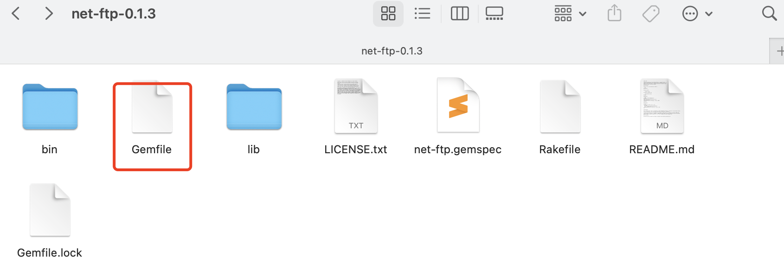

cd /Users/freda.luo/.rvm/gems/ruby-3.1.4/gems/net-ftp-0.1.3

Note: Ensure you are in the directory that contains the Gemfile before running bundle install. This command installs all the dependencies listed in the Gemfile, which are required for your project.

In the project directory, install the necessary Ruby gems by running:

bundle install